To set up Cypress for E2E testing in your Angular 17 app, follow these steps:

<https://www.cypress.io/>

**Step 1: Install Cypress**

Open your terminal and run:

npm install cypress --save-dev

**Step 2: Initialize Cypress**

Run the following command to open Cypress for the first time:

npx cypress open

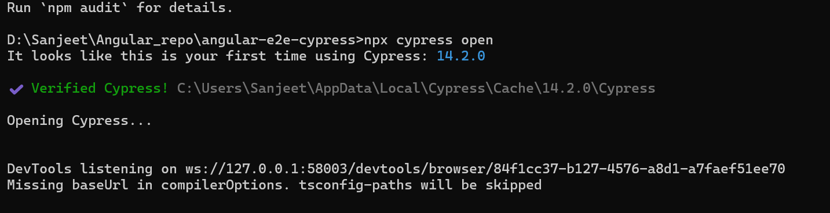

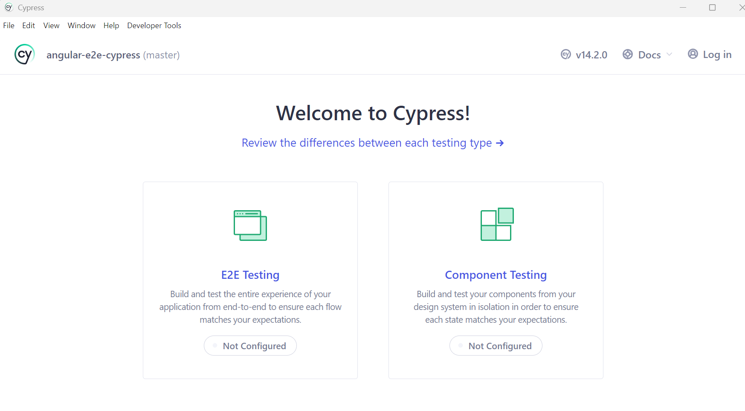

**Step 3: Add Cypress to Angular package.json Scripts**

In your package.json, add this script:

"scripts": {

"e2e": "cypress open"

}

**Step 4: Configure Cypress to work with Angular**

In the cypress.config.js (or cypress.config.ts if you're using TypeScript), set the base URL to your Angular app:

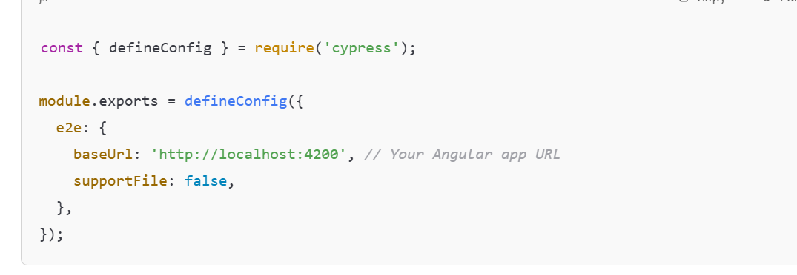

**Step 5: Run Angular and Cypress Together**

In one terminal, run:

ng serve

In another terminal, run:

npm run e2e

**Step 6: Write Your First Test**

Inside the cypress/e2e folder, create a file user-grid.cy.ts:

**Step 7: Run Tests**

Cypress will open the browser where you can run the tests interactively.

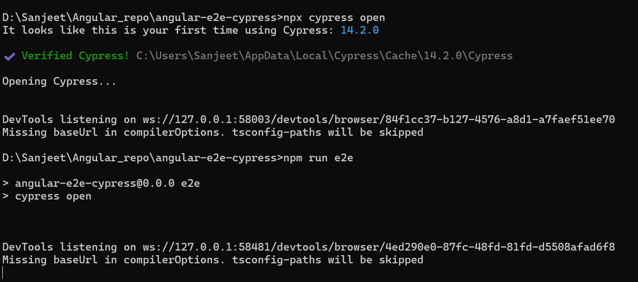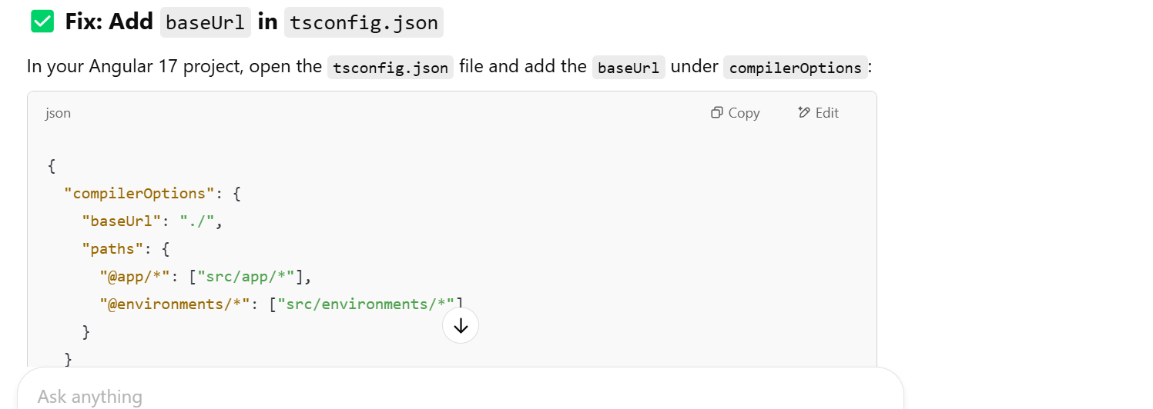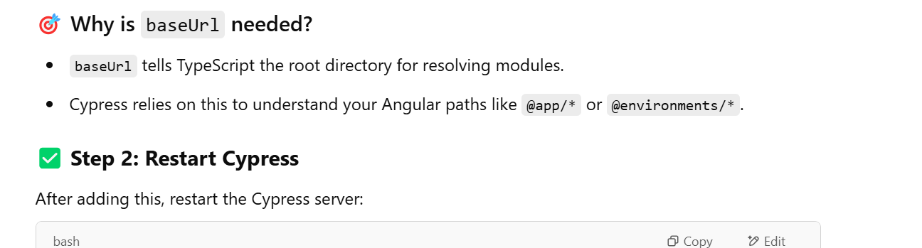

Once unit test is added to cypress/e2e folder (extension- .cy.ts):

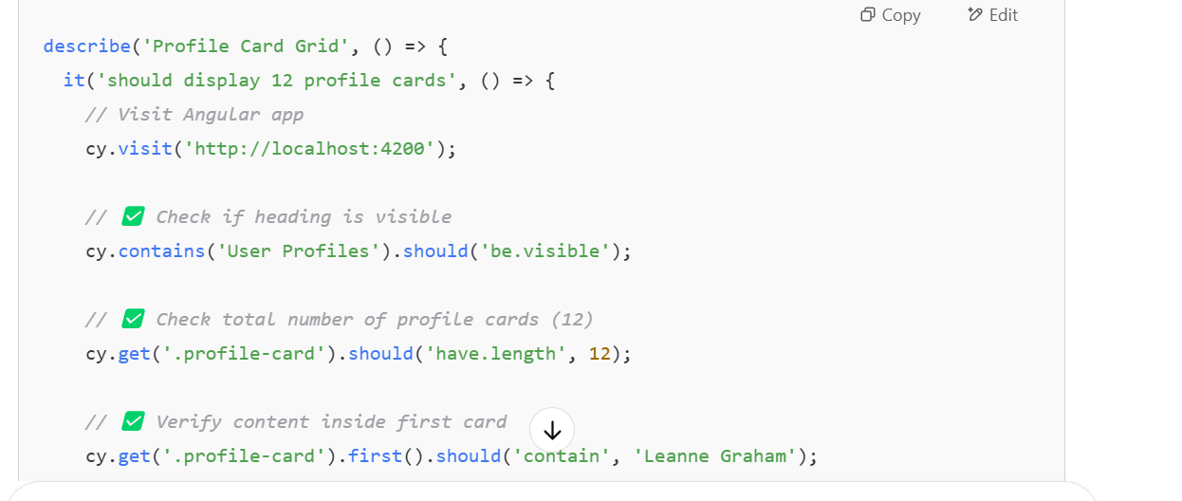

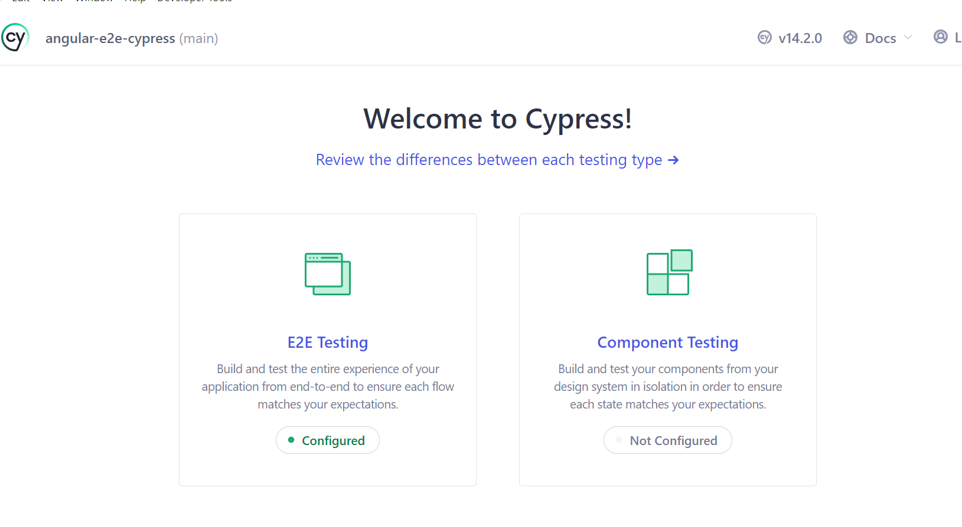

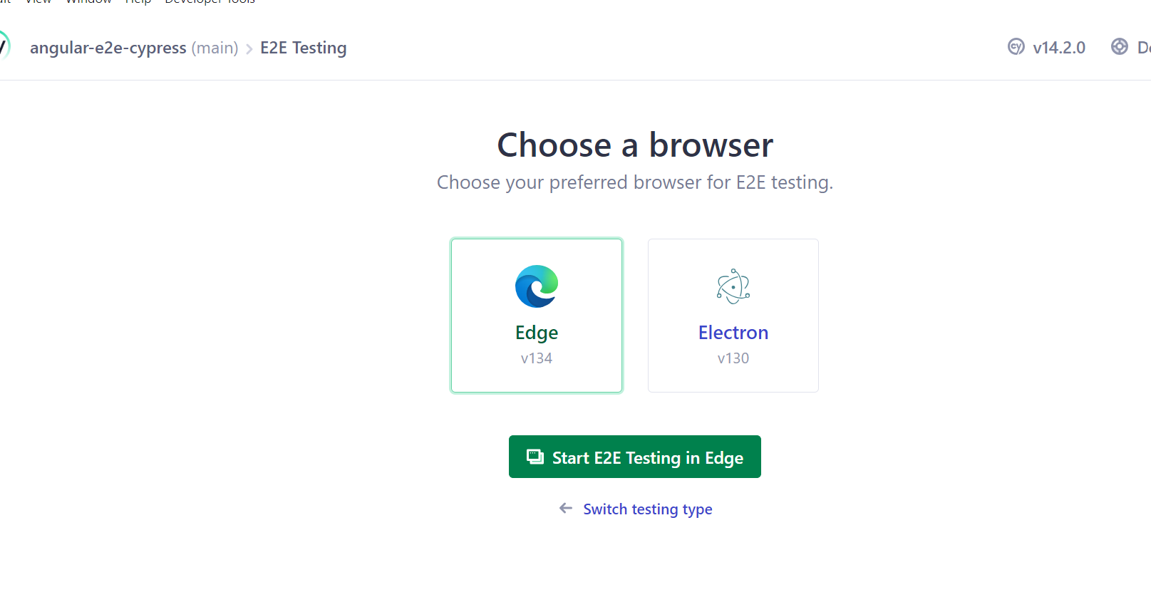

It opens edge

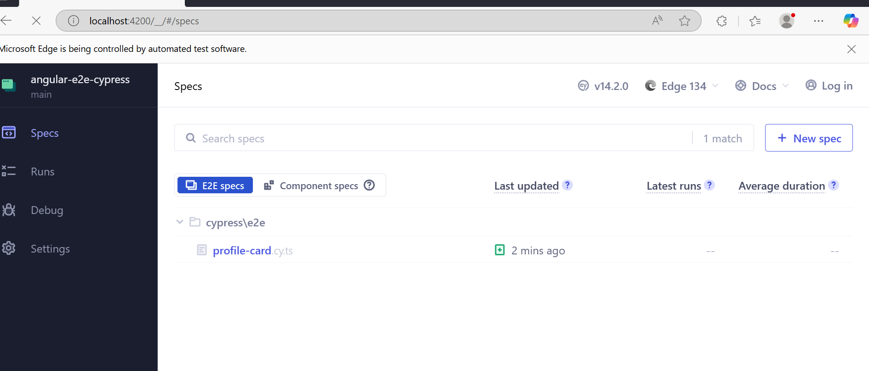

It shows in edge browser

